NETWORK ARCHITECTURE – 1
HOME WORK2

SUBMITTED BY:
RAVI KIRAN KANCHARLA
REG NO. 16067581
MAIL ID: rkqc8@gmail.com

1. Suppose within your Web browser you click on a link to obtain a web page. The IP address for the associated URL is cached in your local host, so a DNS look-up is not necessary to obtain the IP address. Further suppose that the Web page associated with the link references five very small objects on the same server. Let RTT0 denote the RTTs between the local host and one of the object. Assuming zero transmission time of the object, how much time elapses from when the client clinks on the link until the client receives the full web page with
a. Nonpersistent HTTP?
b. Persistent HTTP?

Sol)
Consider we need to obtain a webpage which contains five very small objects on the server. But it was given that the IP address associated with that server is cached in our local host. So here we need not to have DNS look-up for obtaining the IP. Also given that RTT0 denotes the RTTS between the local host and one of the object. Also consider the transmission time of the object is zero.
When the client clicks on the link the total round trip time will depends on the type of the connection used for HTTP.
Here we have two types of connections are available they are
- Nonpersistent HTTP connection
- Persistent HTTP connection

Nonpersistent HTTP connection:
This type of connection needs one RTT for establishing the TCP connection and one RTT for request and response message and this connection will lasts for only one object and if we need to transfer another object it takes two more RTTs for connection, request and response message. So in order to get a webpage from the server the total RTTs will depends on the number of objects in that webpage.

In this Nonpersistent HTTP connection, when the client clicks on the link the total number of RTTs required for transmitting full web page containing five object was 12 RTT0 (two for loading the web page and two for loading each object of that web page. Here we have 5 objects so we need 10 RTT0).

Persistent HTTP connection:
Persistent HTTP connection needs only one TCP connection. When the connection was established, this connection sends all objects of the web page on that single connection. Here the persistent connection uses two concepts. One of them uses pipelining and other use without pipelining.

For the above case when the client clicks on the link, the persistent connection without pipelining needs one RTT0 for establishing the connection and one for loading the webpage and one for each object of that page. So the total RTTs it required are 7 RTT0 for persistent connection without pipelining and 3 RTT0 for the persistent connection which uses pipelining. Because it takes one RTT0 for connection and one RTT0, for sending the main file and one RTT0 for 5 objects.

2. Describe in detail how to register domain names and IP address for your start-up company (what companies to contact, how much is the fee, etc.).

Sol.)
In order to set a web site for start-up companies, they have to register their own domain name and IP address. That domain name may looks like www.websitename.com. This helps the company to keep access to their service details to their customers.
In order to register a domain name and IP, there are different registrars provide domain names different prices ( i.e. 15$, 20$ etc) depends on the registrar.
Some of the popular registrar names are mentioned below.
- Go Daddy
- eNom
- Tucows
- Network Solutions
- 1&1 Internet AG (a.k.a. Schlund.de)
- Melbourne IT (a.k.a INWW.com)
- Wild West Domains (reseller brand of Go Daddy)
- PublicDomainRegistry.com (a.k.a. ResellerClub and Directi)
- Register.com
Go to one of the web sites of above registrars and purchase the domain names.
For example consider the godaddy.com is the most popular registrar. He offers .com domain names for &9.99. They will charge this amount for web interface which helps to manage our domains. It contains pages like starter web, free parked page, etc registered in the name of some proxy companies which offers the extension like .com,.uk, .org, .net etc. By following the steps specified in the registrar site we have to pay them using credit card or using paypal.

3. What is an overlay network? Does it include routers? What are the edges in the overlay network? How is the query-flooding overlay network created and maintained?

Sol)
An overlay network is a virtual network that runs at the top of the existing network for providing the network services which cannot be provided by the existing network. Many of the P2P network are overlay networks. Overlay network does not include routers. The edges in the overlay network are the communication link which connects one node from other and the connection between two nodes is called edge.
The Query flooding overlay network is used in P2P communication system. When the peer at one end need a file which located in another peer, the peer sends a request message to the neighboring peers. This message will compare the file which was requested with files present that neighboring peer. If that file was not matched with the existing files in the neighboring peer then this neighboring peer will generate the same request message to its neighboring peer. This process continues to certain time. If that file was not found within that time, the session will be expired. If the file was found, the peer in which the file was found will send the Query Hit message though the same TCP connection it follows from the requested peer. If more than one location the file was found then the connection will provide the all of its file path to the user i.e. the requested peer so that, it allows the peer to select from which link this file has to be downloaded. When the user clicks that link then request message using GET will be sent. The file will be received with response message and the direct TCP connection will be closed after the file got received. Gnutella, the public sharing application is one of the P2P application which follows overlay network procedure.

4. What is meant by a handshaking protocol? What is/are an example(s) of handshaking protocol?

Sol)
Hand shaking protocol is a method used to establishing a connection between two computers in a network to provide an effective communication among them by some networking tools. This includes the request message from the web browser to server and the file sharing connection between two peers follows two different hand shaking protocols. This hand shaking protocol is used to identify the type of data that was requested and the response it has to give. This hand shaking protocol can occur in one or more steps. For example consider that one computer gives the ping to the other in the form of one packet the response obtained in the form of another packet. This hand shaking may occur in one step. But when we consider the VPN, the request and the response message will take more number of steps including several authentications procedures.
Example of handshaking protocol is TCP. This protocol will provide the necessary interface needed for effective communication between two computers by establishing connection and then allows to send the content request and response packets after the connection is established.

Laboratory Homework

Part 1: Telnet experiments

1. Try HTTP request (GET, HEAD, or POST) without using a web-browser. You can do this on command line using ‘> telnet webserver 80’. (for example, www.umkc.edu) Record the HTTP responses from the server – retrieve at least two different response status from the server.

Sol)
In order to try the HTTP request first we of all we have to download the VPN. This will helps the users to login in to the university network from outside of the network thinking the user as a member. Then we have to download putty which helps the users to connect with the Linux machines like `tux03’. Putty helps the user to connect tux03 of UMKC network through command prompt.
After getting connected to the network we can request the web pages remotely using telnet.
Some of the HTTP request using GET, HEAD without using web-browser is indicated as follows,
The two different request messages using GET method field is displayed as below. Here this was applied on the alumni and friends page of the UMKC web site.

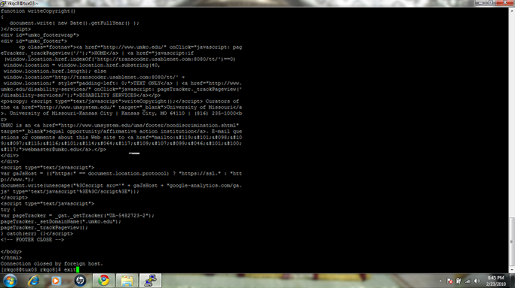

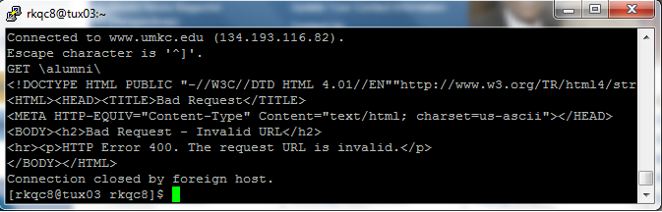

Two different response messages using HEAD method is as follows,

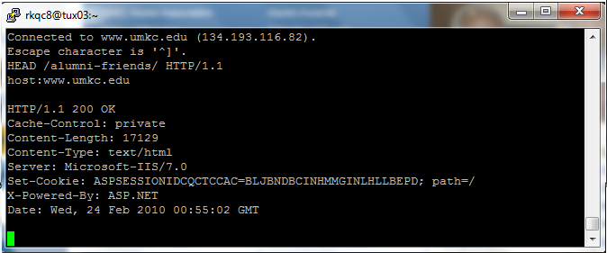

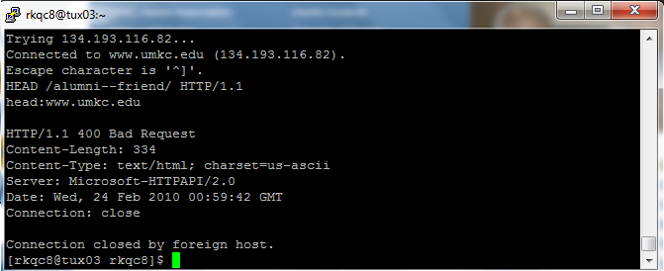

2. Try sending an email without email composer. You can do this on command line using ‘> telnet email_server 25’. Send an email to yourself with a subject (title) and a short content. Then check the email with your regular email reader (Outlook, Eudora, etc.). Record your SMTP message as well as your received email.

Sol)
Here in this experiment we will follow the same steps as it was specified the previous experiment. After that by using the telnet we will connect the mail server of UMKC by using the command in the command prompt as shown below
`telnet smtp1.exchange.umkc.edu 25’. One of the example using SMTP protocol is given below,

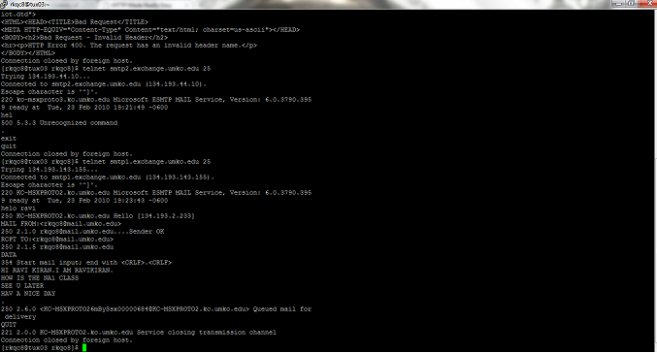

The response mail i got was as shown below,
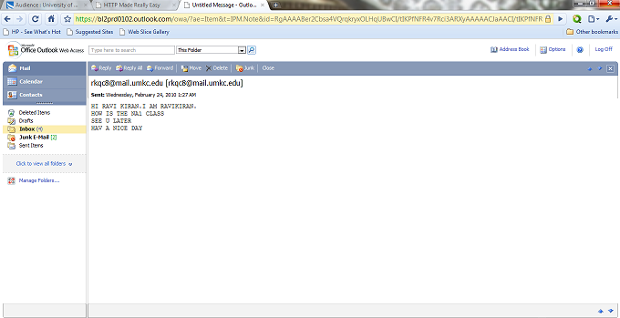
Part 2: Wireshark experiments

In this part of the homework, you will use Wireshark to investigate HTTP protocol in operation. In this lab, you’ll explore a couple of aspects of the HTTP protocol: the basic GET/response interaction, and retrieving large HTML files.
Download a packet trace file (http-ethereal-trace-1) of this homework from the Blackboard, Assignment Section. Or create a trace file on your own following the instruction at the footnote1 from you home (not at University!). Then, open the trace file on the Wireshark, and answer to the questions below.

Part2-1: The Basic HTTP GET/response interaction
Once you open the trace file, it will show in the packet-listing window that two HTTP messages were captured: the GET message (from your browser to the gaia.cs.umass.edu web server) and the response message from the server to your browser. The packetcontents
window shows details of the selected message (in this case the HTTP GET message, which is highlighted in the packet-listing window). Recall that since the HTTP message was carried inside a TCP segment, which was carried inside an IP datagram, which was carried within an Ethernet frame, Wireshark displays the Frame, Ethernet, IP, and TCP packet information as well. We want to minimize the amount of non-HTTP data displayed (we’re interested in HTTP here, and will be investigating these other protocols is later labs), so make sure the boxes at the far left of the Frame, Ethernet, IP and TCP information have a plus sign (which means there is hidden, undisplayed information), and the HTTP line has a minus sign (which means that all information about the HTTPmessage is displayed).
1 FYI, below are the steps taken for the packet capture in the given trace. You don’t collect packets yourself at school due to possible University policy issues.

1. Start up your web browser.
2. Start up the Wireshark packet sniffer. Enter “http” (just the letters, not the quotation marks) in the display-filter-specification window, so that only captured HTTP messages will be displayed later in the packet-listing window. (We’re only interested in the HTTP protocol here, and don’t want to see the clutter of all captured packets).
3. Wait a bit more than one minute (we’ll see why shortly), and then begin Wireshark packet capture.
4. Enter the following to your browser
http://gaia.cs.umass.edu/wireshark-labs/HTTP-wireshark-file1.html
Your browser should display the very simple, one-line HTML file.
5. Stop Wireshark packet capture.

(Note: You should ignore any HTTP GET and response for favicon.ico. If you see a reference to this file, it is your browser automatically asking the server if it (the server) has a small icon file that should be displayed next to the displayed URL in your browser. We’ll ignore references to this pesky file in this lab.).
By looking at the information in the HTTP GET and response messages, answer the following questions. When answering the following questions, you should print out the GET and response messages (see the introductory Wireshark lab for an explanation of how to do this) and indicate where in the message you’ve found the information that answers the following questions.

1. Is your browser running HTTP version 1.0 or 1.1? What version of HTTP is the server running?
2. What languages (if any) does your browser indicate that it can accept to the server?
3. What is the IP address of your computer? Of the gaia.cs.umass.edu server?
4. What is the status code returned from the server to your browser?
5. When was the HTML file that you are retrieving last modified at the server?
6. How many bytes of content are being returned to your browser?
7. By inspecting the raw data in the packet content window, do you see any headers within the data that are not displayed in the packet-listing window? If so, name one.

(In your answer to question 5 above, if you have created your own trace file, you might
have been surprised to find that the document you just retrieved was last modified within
a minute before you downloaded the document. That’s because (for this particular file),
the gaia.cs.umass.edu server is setting the file’s last-modified time to be the current time,
and is doing so once per minute. Thus, if you wait a minute between accesses, the file
will appear to have been recently modified, and hence your browser will download a
“new” copy of the document.)

Sol)
Here by following the above steps to analyze the HTTP packets using the Wireshark software. The packets are analyzed by this software as shown,

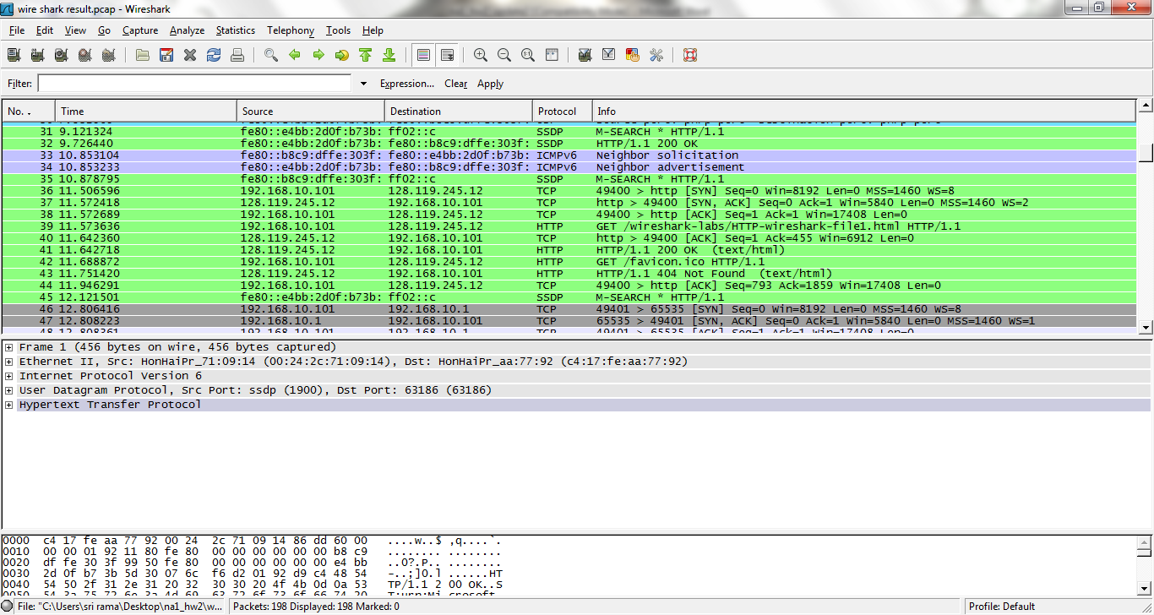

By following the steps in the theory given, the HTTP request and response message are taken as follows
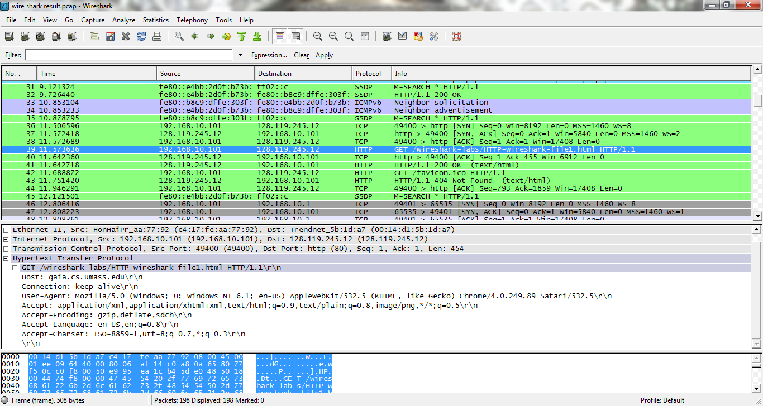

The response packet from the server is as follows,

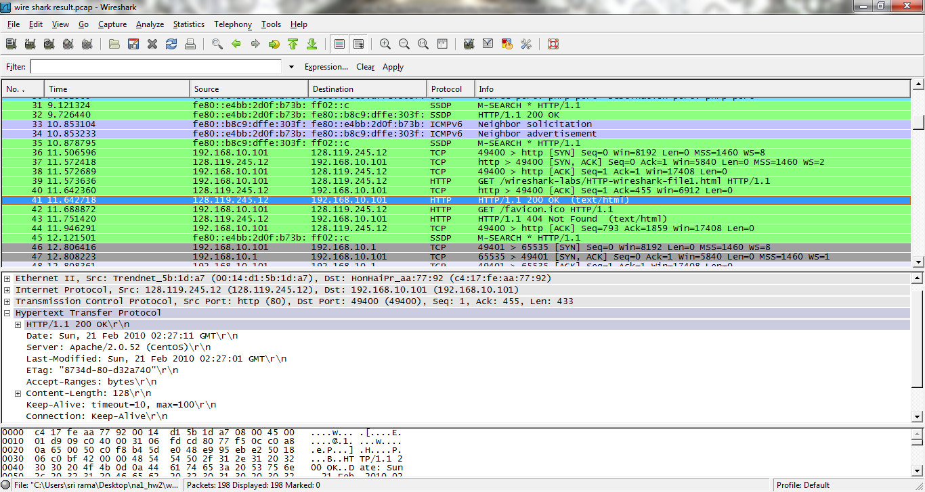

- My browser is running HTTP version 1.1.Ths server is also running HTTP version 1.1
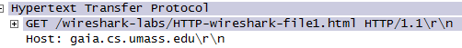
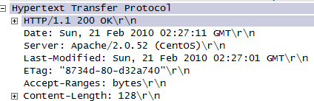

- The browser indicate the language en-us, us.

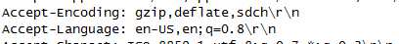

- The IP address of my computer is 192.168.10.101. The IP address of gaia.cs.umass.edu server is 128.119.245.12

- The status code returned from the server to my browser is 200 and phrase is OK.

5.) The HTML file that I had retrieve was last modified at the server is Sunday, 21 st Feb 2010 02:27:01.

6.) The number of bytes of content returned to my browser was 128 bytes.

7.) The raw data that are not displayed in the packet –listing window is Ethernet II,
Src: Trendnet_5b:1d:a7 (00:14:d1:5b:1d:a7),
Dst: HonHaiPr_aa:77:92 (c4:17:fe:aa:77:92)
.
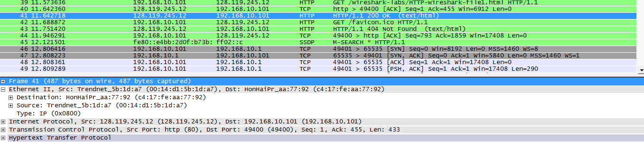

Part 2-2: Retrieving Long Documents

In the previous example, the document retrieved has been simple and short HTML files. Let’s next see what happens when we download a long HTML file.
Download a packet trace file (http-ethereal-trace-3) of this homework from the Blackboard, Assignment Section. Or create a tracefile following the instruction at the footnote2 from you home (not at University!)
Then, open the trace file on the Wireshark and answer to the questions below.
In the packet-listing window, you should see your HTTP GET message, followed by a multiple-packet response to your HTTP GET request. This multiple-packet response deserves a bit of explanation. Recall that the HTTP response message consists of a status line, followed by header lines, followed by a blank line, followed by the entity body. In the case of our HTTP GET, the entity body in the response is the entire requested HTML file. In our case here, the HTML file is rather long, and at 4500 bytes is too large to fit in one TCP packet. The single HTTP response message is thus broken into several pieces by TCP, with each piece being contained within a separate TCP segment (see Figure 1.24 in the text). Each TCP segment is recorded as a separate packet by Wireshark, and the fact that the single HTTP response was fragmented across multiple TCP packets is indicated by the “Continuation” phrase displayed by Wireshark. We stress here that there is no “Continuation” message in HTTP!

Answer the following questions:
1. How many HTTP GET request messages were sent by your browser?
2. How many data-containing TCP segments were needed to carry the single HTTP response?
3. What is the status code and phrase associated with the response to the HTTP GET request?
4. Are there any HTTP status lines in the transmitted data associated with a TCP induced “Continuation”?
2 Start up your web browser, and make sure your browser’s cache is cleared (To do this under Firefox, select Tools->Clear Private Data, or for Internet Explorer, select Tools- >Internet Options->Delete File; these actions will remove cached files from your browser’s cache.)
1. Start up the Wireshark packet sniffer
2. Enter the following URL into your browser
http://gaia.cs.umass.edu/wireshark-labs/HTTP-wireshark-file3.html
Your browser should display the rather lengthy US Bill of Rights.
3. Stop Wireshark packet capture, and enter “http” in the display-filter-specification Window, so that only captured HTTP messages will be displayed.
Sol.)
Here by using the Wireshark I have captured the HTTP packets by following the steps mentioned in the question. The response of Wireshark is as follows.
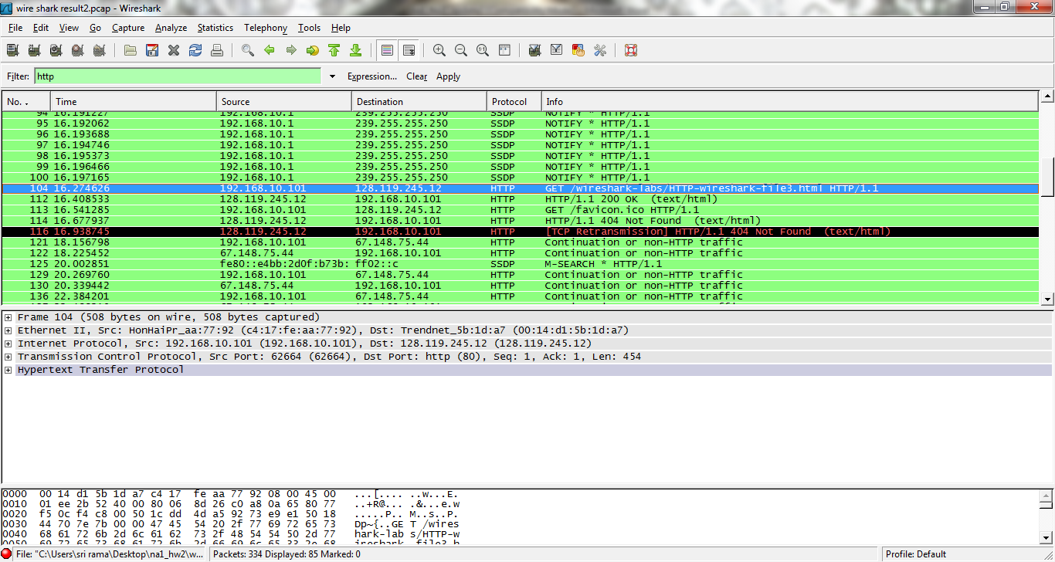
The request packet analyzed by using Wireshark is shown in below.
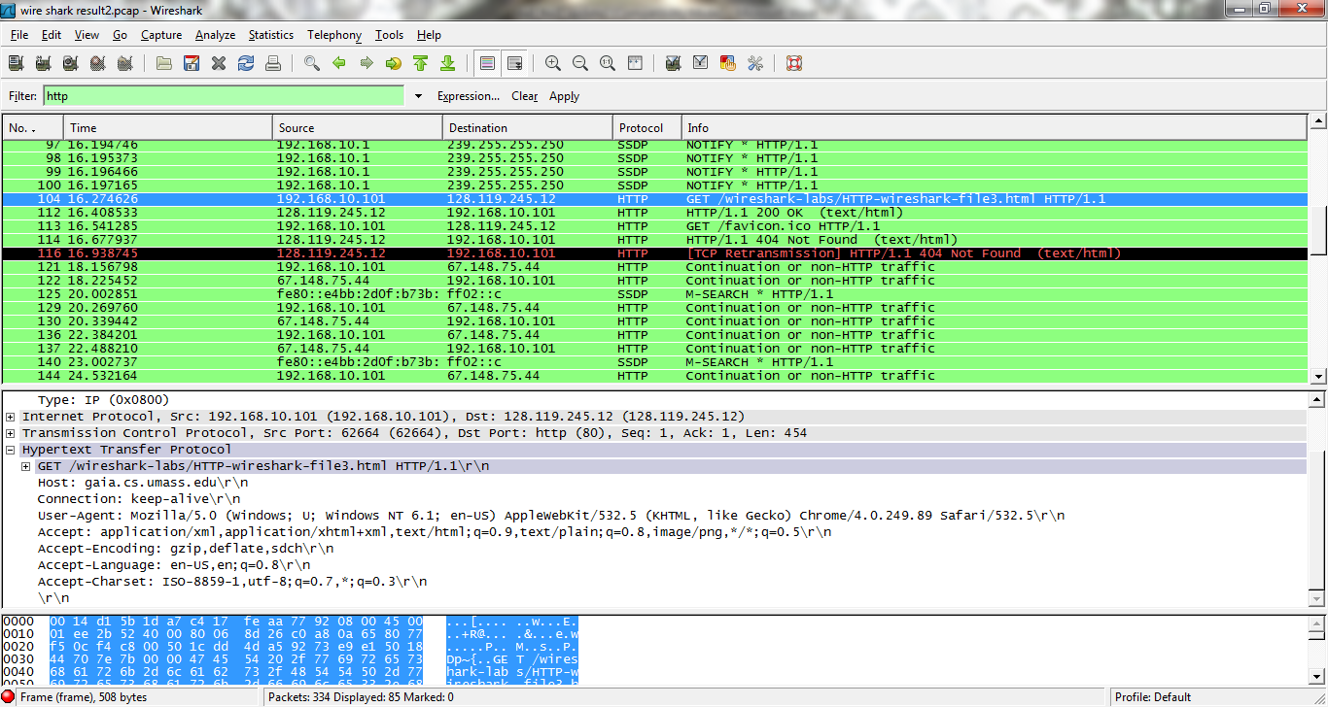
The response message of the packet send by the server is as follows.
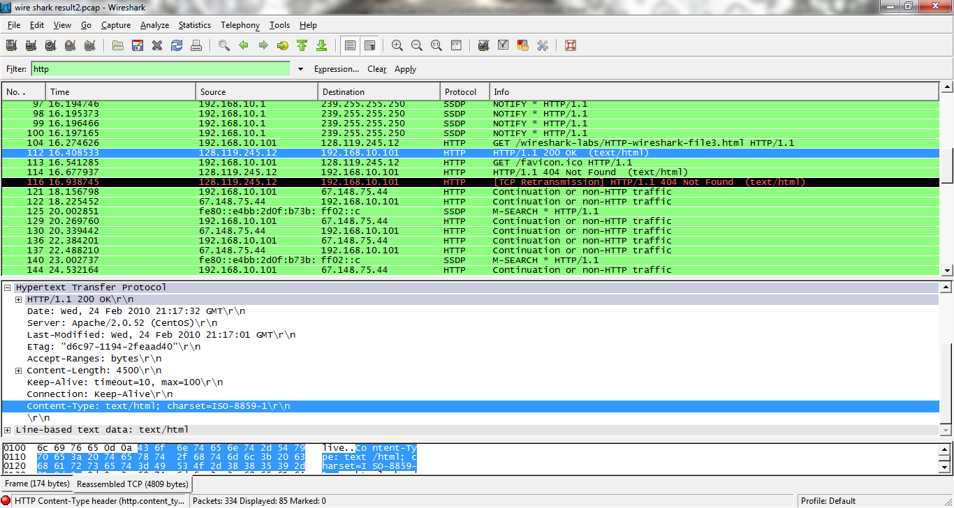
- One HTTP GET request message was sent by my browser.
- In order to carry the single HTTP response it needs 4 data-containing TCP segments.

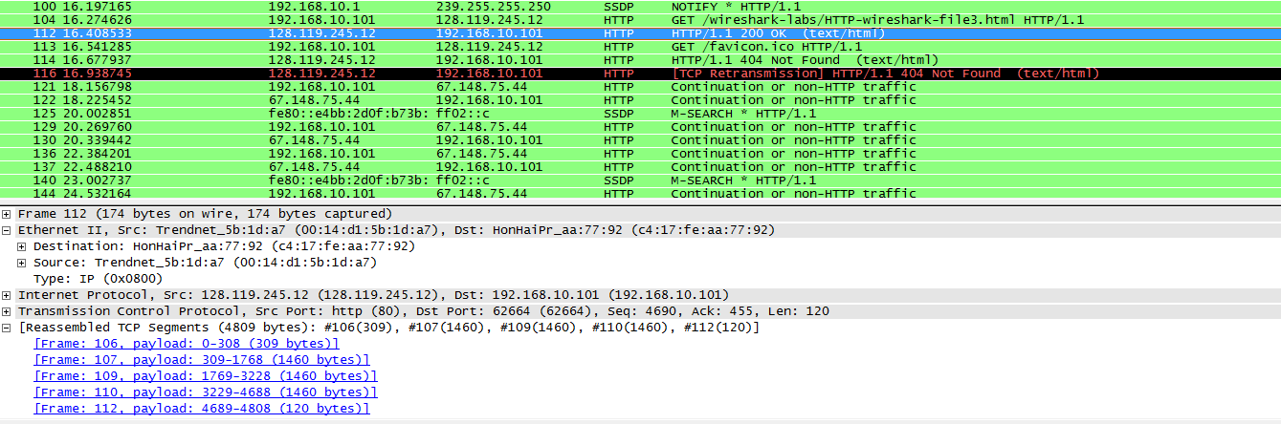
- The status code is 200 and phrase is OK.
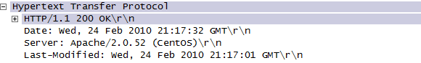
4. None of the status lines in the transmitted data.

References:
1. http://en.wikipedia.org/wiki/List_of_domain_name_registrars

